*Florida International University*

*School of Computing and Information Sciences*

Software Engineering Focus

Feature Document

User Story ID #661

**Name:** Kyle Ryan

**Team Member(s):** Mario Fidalgo

**Project:** Mobile Judge 9.0

**Product Owner(s)**: Masoud Sadjadi

**Mentor(s)**: Masoud Sadjadi

**Instructor**: Masoud Sadjadi

**User Story Name:** Modify Judges Registration Form Descriptions

* Description: As an admin, I would like to have a user-friendly and easy to understand registration form, so that I can easily guide new Judges as they register.

Acceptance Criteria

* When registering as a Judge I should be able to understand what each field is for.
* When I register as a Judge I should be able to understand who I should pick as a conflict.

**Use Case**

* Name: Register as a Judge
* Actor: Prospective Judge
* Preconditions: User must be invited to be a judge.
* Description <Flow of events>:

1. User clicks Accept in email invite.

2. System displays required fields to register as a Judge.

3. User populates required fields.

4. System verifies and adds new Judge to database and displays conflicts page.

5. User chooses conflicts or skips.

5. System completes registration.

**Use Case Diagram**

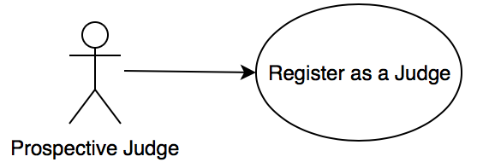

**Sequence Diagram**

**Class Diagram**

**Unit Test & Integration Test**

**Test case ID:** MJ-661-01 **Description/Summary of Test:** Prospective judge registers  
**Precondition:** A prospective judge registers to MobileJudge **Expected Results:** All the fields in the registration form should be saved as a field in the database. **Actual Result:** Each field was successfully saved in the database including salutation **Status (Fail/Pass):** Pass

**Test case ID:** MJ-661-02 **Description/Summary of Test:** Prospective judge registers  
**Precondition:** A prospective judge registers to MobileJudge **Expected Results:** Examples of what should be in each field should be shown. **Actual Result:** Each field had an example of what was required for the field **Status (Fail/Pass):** Pass

**Test case ID:** MJ-661-03 **Description/Summary of Test:** Prospective judge registers  
**Precondition:** A prospective judge registers to MobileJudge **Expected Results:** Description of how to select conflicts of interest should give a judge the correct idea on who to select in this phase. **Actual Result:** The description was clear and concise allowing the phase to be easy to understand. **Status (Fail/Pass):** Pass

**Test case ID:** MJ-661-04 **Description/Summary of Test:** Prospective judge registers  
**Precondition:** A prospective judge registers to MobileJudge **Expected Results:** Once registration is complete the judge’s account should be created. **Actual Result:** The account is created once the registration is complete. **Status (Fail/Pass):** Pass

**Visual User Guide**

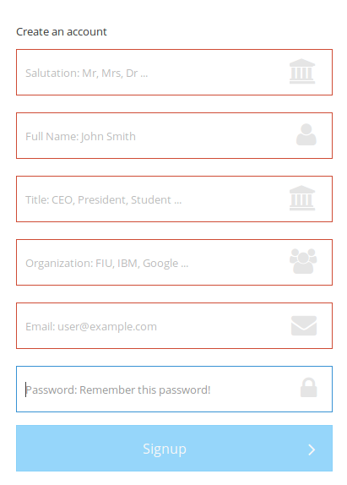

This the registration form when a prospective judge accepts an invitation.

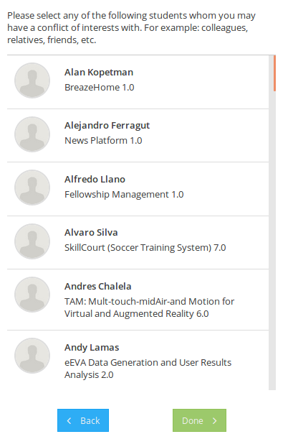

The following step is to select conflicts of interest with particular students, when done the account will be created.